Guidance for Egg Producers, Craft Food and Cottage Food Operations during COVID-19 Pandemic
Plant Industry and Food and Nutrition Divisions

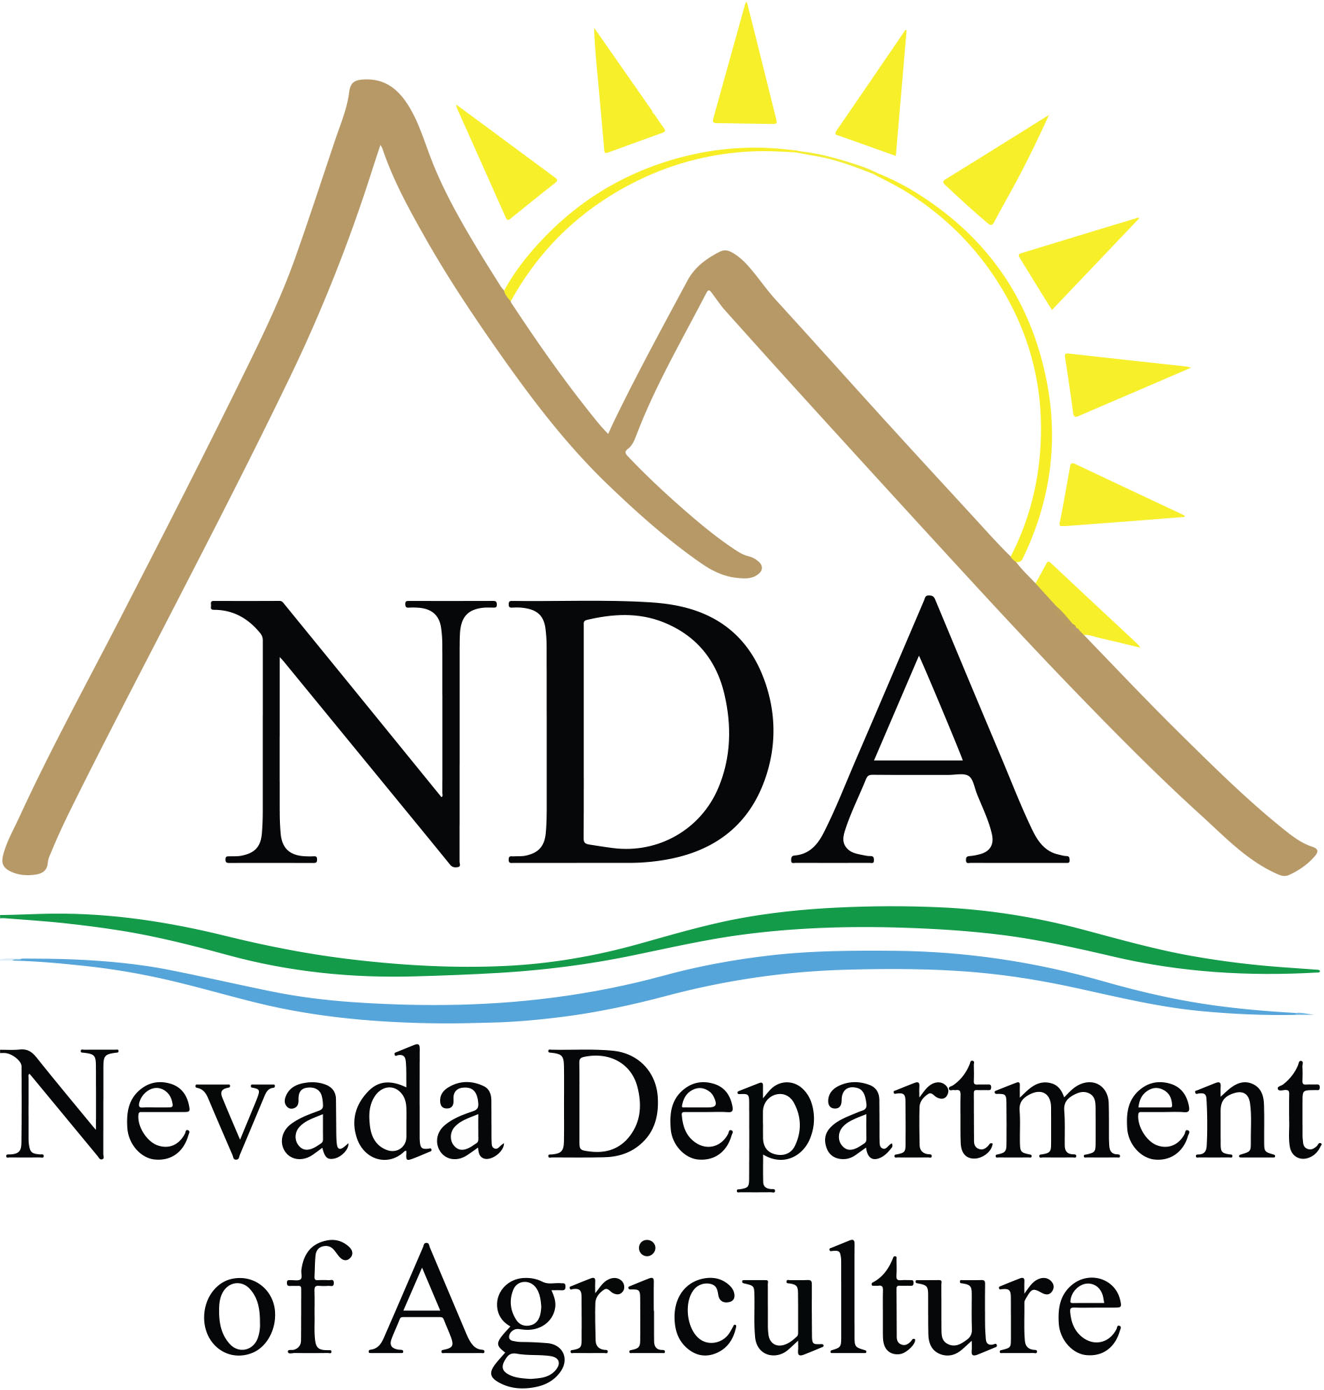

April 27, 2020
This guidance is based on what is currently known about the transmission and severity of COVID-19 and information made available by Nevada Health Response. The Nevada Department Agriculture (NDA) will update this guidance as needed and as additional information becomes available. Local agencies may have additional guidance and/or requirements regarding these operations in their jurisdiction.

Recommended Precautions for Egg Producers and Craft Food Operations
Agriculture has been deemed “essential” under Governor Sisolak’s directives. As the risk of transmission of COVID-19 remains high, it is important for those farmers who sell raw and unprocessed crops of their own production, including honey and eggs, as well as permitted craft food operations, to take precautions to reduce the spread.
The NDA is currently processing producer certificate renewals and issuing temporary certificates to new applicants until inspections can be safely conducted. Egg producers selling direct to consumers may continue to do so when adhering to guidance below. The NDA is not processing new craft food operation applications or conducting testing at this time.

Egg Producers and Craft Food Operations Guidance
In addition to standard kitchen sanitation and food safety guidelines we suggest implementing the following:

Social distancing
- Offer contactless payment options and pick-up or delivery.
- Set designated times for individual customers to pick up their purchase.
Cleaning and protecting individual health
- Wear face coverings whenever interacting with customers and refrain from touching the covering.
- Avoid touching your eyes, nose and mouth.
- Wear single-use protective gloves if possible when interacting with customers. Always wash hands prior to putting on gloves and after removing them. Change gloves after handling money or touching your eyes, nose or mouth.
- Application of Guidelines for Safe Food Handling During COVID-19 Outbreak should be referenced.
- Staff should wash hands often with warm water and soap or use an alcohol-based gel before and after handling products.
- Equipment should not be shared between individuals. If it must be shared, it should be thoroughly cleaned and disinfected before and after use.
- Sanitize food contact surfaces per food safety guidelines.
- Sanitize non-food contact surfaces. Follow manufacturer instructions for cleaning products. Click here for a list of EPA-approved emerging pathogen sanitizers.
Monitoring illness
- Monitor for signs of illness such as shortness of breath, coughing or fever.
- Anyone experiencing signs of illness should stay home, contact their healthcare provider and follow CDC-recommended steps.
- If anyone becomes sick:
  - Stop sales from the home.
  - Close off areas used by the sick person.
  - 24 hours (or as long as possible) before you clean or disinfect.
  - Clean and disinfect all areas used by the sick person, such as offices, bathrooms, common areas, and shared electronic equipment like tablets and computers.
  - Please reference the CDC’s Disinfecting Your Facility If Someone Is Sick for guidance.

Cottage Food Businesses Guidance
Cottage Food licenses fall under the health authority. Please refer to specific guidance from your applicable Health District to determine if selling is allowed and deemed “essential” for current permit holders during the pandemic.

- Nevada Department of Health and Human Services, Division of Public and Behavioral Health, Environmental Health Section has authority for all counties in Nevada except those listed below.
- Carson City Health and Human Services has authority for Carson and Douglas counties.

- Washoe County Health District has authority for Washoe County.
- Southern Nevada Health District has authority for Clark County.

Resources
See the Guidance for Farmers Markets, Farm Stands and CSAs during COVID-19 Pandemic for those still able to sell at this time.
Latest updates related to Nevada agriculture industries during COVID-19 can be found at agri.nv.gov/industry_resources_covid19.

