Nevada Board of Agriculture
Meeting & Public Hearing for Adoption of LCB File
No. R100-200 minutes
Wednesday, December 8, 2021 9:00am

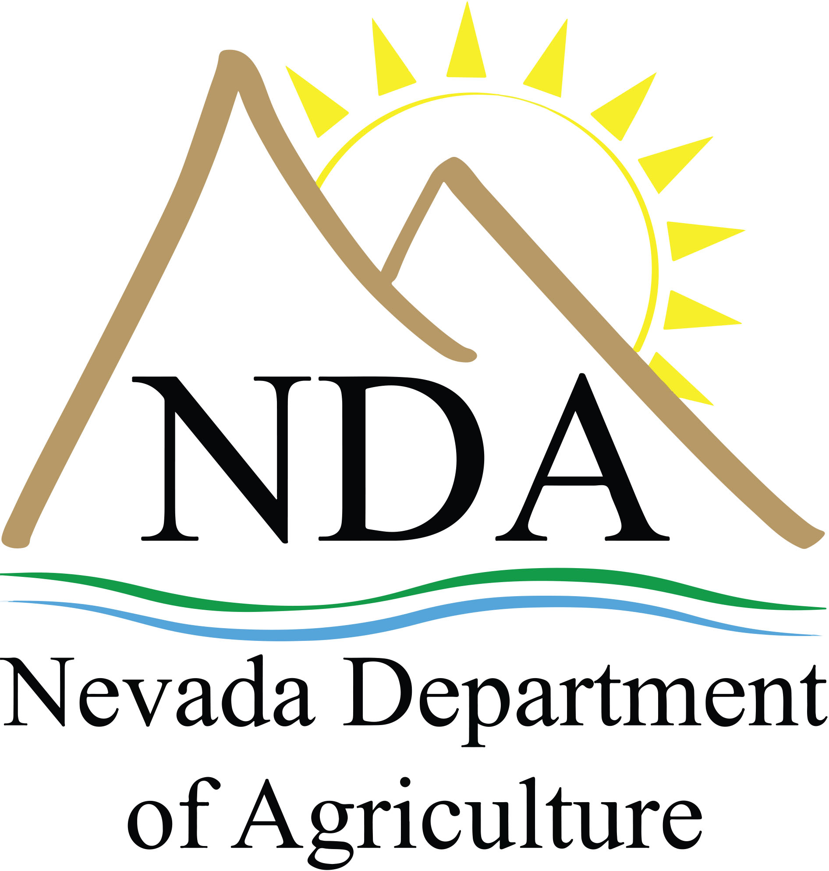

Meeting Location: Nevada Department of Agriculture
2300 East St. Louis Avenue
Las Vegas, NV 89104
702-668-4590

Video Conference: Nevada Department of Agriculture Nevada Department of Agriculture
405 South 21st Street 4780 East Idaho Street
Sparks, NV 89434 Elko, NV 89801
775-353-3601 775-778-0270

Virtual Meeting https://us02web.zoom.us/j/81738268429
Information: Meeting ID: 817 3826 8429
Phone: +1-669-900-9128
Phone Access Code: 817 3826 8429

COVID-19 Notice

ALL PERSONS WISHING TO ATTEND AT PHYICAL LOCATIONS ARE REQUIRED TO WEAR A MASK IN ACCORDANCE WITH EMERGENCY DIRECTIVE 047

Public notice
Below is an agenda of all items to be considered. Action may be taken on items preceded by an asterisk (*). Two asterisks denote possible closed session (**). Items on the agenda may be taken out of the posted order, items may be combined for consideration, and items may be pulled or removed from the agenda at any time at the discretion of the chairperson. Unless noted as an action item, discussion of any item raised during a report or public comment is limited to that necessary for clarification or necessary to decide whether to place the item on a future agenda.

Public comment may be presented in-person (if there is a physical meeting location), by computer, phone, or written comment. Written comments may be submitted by completing a public comment form available online at http://agri.nv.gov/Administration/Board_of_Agriculture/Board_of_Agriculture_Public_Comment/. Written comments can also be submitted via fax to 775-353-3661, email to sbellwood@agri.nv.gov or to any of our offices listed below.

  - Nevada Department of Agriculture: 405 S. 21st Street, Sparks, NV 89431
  - Nevada Department of Agriculture: 4780 E. Idaho Street, Elko, NV 89801
  - Nevada Department of Agriculture: 2300 E. St. Louis Avenue, Las Vegas, NV 89104

The chairperson may limit public comment that is repetitious, does not relate to a matter within the board’s jurisdiction or prevents the meeting from continuing in an orderly manner. All public comment should be addressed to the Board of Agriculture and not an individual member. The board asks that your comments are expressed in a courteous manner. All public comment is limited to three minutes per person. Unused time may not be reserved by the speaker nor allocated to another speaker.

Reasonable efforts will be made for members of the public who have disabilities and require special accommodations for assistance at the meeting. Please call Samantha Bellwood at 775-432-4263.

Notice of this meeting was posted on or before 9 a.m. on the third working day before the meeting at the following locations: Nevada Department of Agriculture, 405 S. 21st Street, Sparks, NV 89431, Nevada Department of Agriculture, 4780 E. Idaho Street, Elko, NV 89801, Nevada Department of Agriculture, 2300 St. Louis Avenue, Las Vegas, NV 89104, State of Nevada Capitol Building, Carson City NV, State Library and Archives, Carson City. Copies of the agenda, supporting documentation and meeting minutes are available, at no charge, at the Nevada Department of Agriculture website at agri.nv.gov or www.notice.nv.gov or by visiting the Nevada Department of Agriculture, 405 S. 21st Street, Sparks, NV 89431.

Agenda

- Open meeting-call meeting to order by Chair Woody Worthington

- Pledge of Allegiance
- Moment of Silent Reflection
- Roll call

Members in attendance: Woody Worthington, Duane Coombs, David Coon, Valerie Drake, Charlie Frey, Varlin Higbee, Heather Lackey, Paul Noe, Pete Paris, Bernard Petersen, Jim Snyder

NDA staff in attendance: Jennifer Ott, Jerri Conrad Williams, Samantha Bellwood, Doug Farris, Cadence Matijevich, Ashley Jeppson, Homa Anooshehpoor, Richard Yien, Dr. Amy Mitchell Patricia Hoppe, Amber Smyer, Ciara Ressel, Mikayla Jones, Dillon Davidson, Scott Clifford, Valerie Hoffman

The meeting was called to order at 9:00am.

- Public Comment

Demar Dahl, on behalf of the Nevada Lands Council, presented public comment recommending the board to discuss the Nevada Lands Council’s resolution on eliminating brand inspections for movement of livestock within the state.

Mark Zeller submitted public comment requesting the board address the management of the Virginia Range feral/estray horses in the Hidden Valley neighborhood located in Reno, NV.

- Minutes

  - *Approve September 8, 2021 minutes (for possible action)

Paul Noe moved to approve the September 8, 2021 minutes. Charlie Frey seconded the motion. The motion was passed unanimously.

4. New Member Introduction

A. New member, Duane Coombs, introduction – Woody Worthington, Chair (for information only)

5. Board Management

A. Board of Agriculture 2022 meeting dates – Samantha Bellwood, Executive Assistant (for information only)
i. March 9, 2022
ii. June 8, 2022
iii. September 14, 2022
iv. December 14, 2022

6. Board Member Updates on Represented Industries

A. Industry updates – Board Members (for information)
7. Director’s Report

- Report – Jennifer Ott, Director (for information)

8. Food and Nutrition

A. Board update – Homa Anooshehpoor, Administrator (for information)

9. Consumer Equitability

A. Board update – Cadence Matijevich, Administrator (for information)

10. Plant Industry

A. Board update – Ashley Jeppson, Administrator (for information)
B. *Purchase order approval to use funds from 4544-10, Assessment for Alfalfa Seed research for payment to the National Alfalfa Forage Alliance and Western Alfalfa Seed Growers Association (for possible action)

Duane Coombs moved to approve the use funds from 4544-10, Assessment for Alfalfa Seed research for payment to the National Alfalfa Forage Alliance and Western Alfalfa See Growers Association. Paul Noe seconded the motion. The motion was passed unanimously.

C. 2021 Specialty Crop Block Grant Award – Ashley Jeppson, Administrator (for information)

11. Animal Industry

A. Board update – Doug Farris, Administrator (for information)
B. *Discussion and adoption of proposed regulations for LCB File No. R100-200 regarding the amendment of regulations pertaining to chapter 565 of the Nevada Administrative Code – Doug Farris, Administrator (for possible action)

In addition to the attendees listed in Agenda Item #1, attendees included Doug Busselman, Peter Krueger, Demar Dahl, Marti Hoots, Randy Robinson, Leana Carey, Alex Tanchek, Nikole Robinson Carroll, Curt Stock, Mark Ono, and Debbie Gilmore.

Administrator Farris opened the hearing for the adoption of proposed regulations for LCB File No. R100-200 regarding the amendment of regulations pertaining to chapter 565 of the Nevada Administrative Code at 11:06am.

Public comment was opened, and no public comment was received.

Administrator Farris provided an overview of the proposed changes and the need for revising the regulations. Previous regulation changes to Nevada Administrative Code (NAC) 564 and NAC 565 were adopted on September 9, 2021. This final adoption hearing for NAC 565 was for the specific portion under board authority to revise the horse permit fees.

Board Member, Duane Coombs, requested confirmation if the $35 travel fee to each place of inspection is per location. Administrator Farris confirmed that it is. Board Member, Jim Snyder, stated that he had no objection to the proposed regulation changes and hoped that the changes make the Livestock Inspection program successful.

Vice Chair Varlin Higbee requested clarification on the regulations being adopted. Administrator Farris confirmed that the hearing was to adopt regulations in NAC 565 section 2 (horse permit fees). Vice Chair Higbee also inquired if the inspection fees cover the cost of the program and Administrator Farris confirmed that they would.

The public comment period was reopened. Peter Krueger provided public comment relating to the reuse of underground fuel tanks for water storage for livestock use. Mr. Krueger mentioned that the Nevada Farm Bureau received 6 inquires of interest in reusing underground fuel tanks and agreed that fiberglass tanks cannot be reused, but steel tanks could.

Board member, Valerie Drake mentioned that she had confirmed with Idaho that they have regulations pertaining to the reuse of underground fuel tanks for water storage and would like Nevada to consider similar regulations. Mr. Krueger stated that there are no federal regulations prohibiting the reuse of underground fuel tanks.

Jim Snyder moved to adopt the proposed regulations for LCB File No. R100-200 regarding the amendment of regulations pertaining to chapter 565 of the Nevada Administrative Code. Bernard Petersen seconded the motion. The motion to adopt proposed regulations for LCB File No. R100-200 regarding the amendment of regulations pertaining to chapter 565 of the Nevada Administrative Code passed 8-3.

The hearing was closed at 11:34am.

12. Administration

A. Board update – Jerri Conrad, Deputy Director (for information only)

13. Public Comment

No public comment.

14. Adjournment

